My project represents a reinventing of the classic arcade game space invaders. My original idea was to create a memory matching game, but with the time allotted it would have been too difficult to implement a finished product. My project features three game states: The main screen, the play state, and game over. The player is told to click the joystick to begin the game. The player must use the joystick to move their spacecraft across the x-axis on the screen and blast the invaders with a mouse click. Whenever an invader is hit the red led light installed on the bread board will flash and the player’s score will increase by one. Once the timer counts down in 30 seconds the player is brought to a game over screen where they are invited to press the ‘P’ key to play again.

Main screen Play state

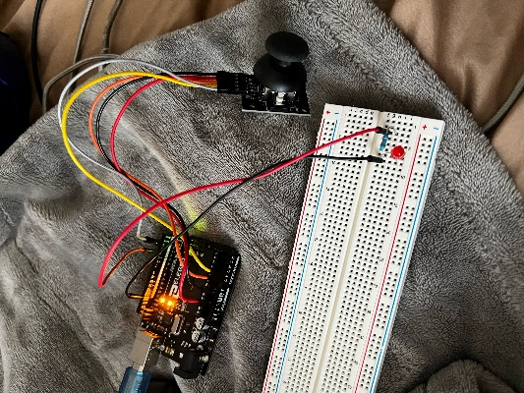

Game Over

Arduino setup

Considering future developments, I would like to add in a score recording mechanism that will save the players score to make the game more competitive. I also want to add more levels to make the game design more dynamic.